Dear Parents and Carers,

The book fair is back at Whitmore Park and will be open Monday 12th October – Thursday 15th October after school.
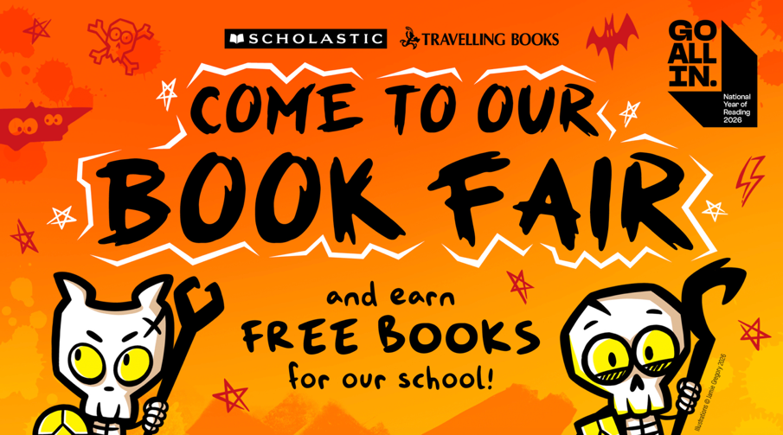

The times and dates that the book fair will be open are as follows:

Date | Time | Place
Monday 12th October 2026 | 3.30pm – 4.00pm | The library
Tuesday 13th October 2026 | 3.30pm – 6.00pm (Year 1-6 parents’ Evening) | The library
Wednesday 14th October 2026 | 3.30pm – 4.00pm | The library
Thursday 15th October 2026 | 3.30pm – 4.00pm | The library

There are over 200 titles for you and your child to choose from and we will give all the children the opportunity to browse the books beforehand so that they can create their wish list.
Prices start from as little as £3.99 so there’s sure to be a book for everyone.
When you come to the book fair, there is the option to pay by cash or card.
Don’t forget that every book you buy can help to get FREE BOOKS for the school, which we then use to supplement our class libraries so every child in school benefits from the books we receive.
Kind regards,
Miss Knowles
English Lead

